Timeline Shows 3 Paths To COVID-19 Treatment And Prevention (INFOGRAPHIC)

John CumbersSenior Contributor
Manufacturing
Synthetic biology & space settlement connector, founder and investor.
- In uncertain times, we are witnessing one of the greatest moments in the history of science.

A projected timeline for treatment and prevention of the novel coronavirus.
Scientists are breaking speed records in their race to develop treatments for the new coronavirus. Some are panning through old molecules hoping to find effective drugs. Others are applying the latest breakthroughs in synthetic biology to engineer sophisticated treatments and vaccines.
I’ve previously talked about some synthetic biology companies that are racing to create treatments. Others like Mammoth Biosciences are developing much-needed testing. Every day brings additional reports of the latest breakthroughs from around the world. But how can we make sense of all this information?
To provide a big-picture perspective, SynBioBeta and Leaps by Bayer have partnered to help visualize the overall progress of the research community. At the heart of the project is an infographic showing the timeline to the various treatments and preventions (click here to download it). It’s based on data from The Milken Institute, which recently released a detailed tracker to monitor the progress of each of the more than 60 known COVID-19 treatments and preventions currently in development.
One takeaway: the progress to develop coronavirus treatments and preventions is moving at an unprecedented pace, with historic records being broken nearly every week.
“The crisis response from the global biotech community has been truly inspiring,” says Juergen Eckhardt, SVP and Head of Leaps by Bayer, a unit of Bayer AG that leads impact investments into solutions to some of today’s biggest challenges in health and agriculture. “We are excited to partner on this visual timeline to help a broader audience understand how and when scientific innovation may bring us through this deeply challenging time”.
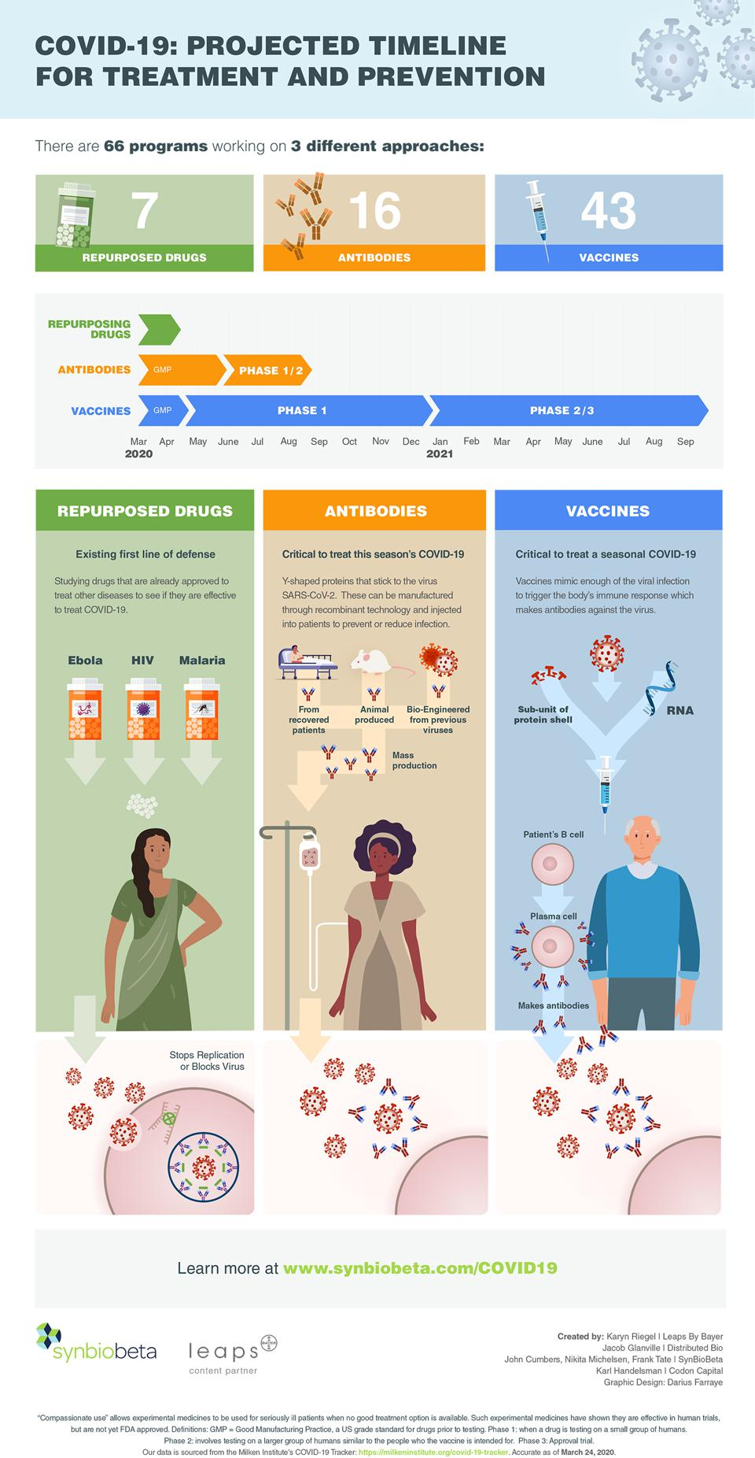
There are standard stages to getting a drug approved. In Phase 1 trials, a drug’s safety is assessed in a small group of healthy subjects. In later stages (Phase II & III), efficacy is measured in a larger number of people, often versus a placebo. The situation with COVID-19 is predicted to become so dire so quickly, however, that many are looking to fast-track testing. This could include granting experimental drugs ‘expanded access,’ for compassionate use, which would allow physicians to give them to patients who are critically ill before testing is complete.

Repurposing Existing Drugs
The fastest way to safely stop COVID-19 would be to discover that an already-approved medication works against it. Repurposed drugs do not require the same extensive testing as novel medicines and may already be available in large quantities. The Milken Institute’s tracker identifies 7 candidate drugs in this category.
One is the malarial medicine chloroquine, which in recent days has been touted by some as a possible miracle drug against the coronavirus. German pharmaceutical company Bayer last week donated three million tablets of chloroquine to the U.S. The FDA and academics are together investigating whether it can provide relief to COVID-19 patients.
There are hundreds if not thousands of other FDA-approved drugs on the market that are already proven safe in humans and that may have treatment potential against COVID-19, so many scientists are rapidly screening the known drug arsenal in hopes of discovering an effective compound.

Anti-Coronavirus Antibodies
Antibodies are proteins that are a natural part of the human immune system. They work around the clock in blood to block viruses and more. The problem at the moment is that because the novel coronavirus (known as SARS-CoV-2) is new, no one has had time to develop antibodies against it. No one, that is, except those who have recovered from COVID-19.
Antibodies taken from those people could help patients who are still infected. Such patient-to-patient transfers can be performed without extensive testing or lengthy approval processes so long as standard protocols are followed. It is yet unknown whether this treatment option will work for COVID-19, nor whether there will be enough recovered donors to deal with the infection at scale.
To improve this process, companies like Vancouver, Canada-based AbCellera are applying new biotechnologies.
AbCellera is using proprietary tools and machine learning to rapidly screen through millions of B cells from patients who recovered from COVID-19. B cells are responsible for producing antibodies. The company has announced a partnership with Eli Lilly on this project and aims to bring its hottest antibodies — those that neutralize the virus —to the clinic.
“AbCellera's platform has delivered, with unprecedented speed, by far the world's largest panel of anti-SAR-CoV-2 antibodies," said Carl Hansen, Ph.D., CEO of AbCellera, in a statement. "In 11 days, we've discovered hundreds of antibodies against the SARS-CoV-2 virus responsible for the current outbreak, moved into functional testing with global experts in virology, and signed a co-development agreement with one of the world's leading biopharmaceutical companies. We're deeply impressed with the speed and agility of Lilly's response to this global challenge. Together, our teams are committed to delivering a countermeasure to stop the outbreak."
James Crowe at Vanderbilt University is also sifting through the blood of recovered patients. Using a new instrument called Beacon from a company called Berkeley Lights. Crowe’s team has been scouring through B cells to find antibodies that neutralize SARS-CoV-2. The technology behind this project was developed in recent years with funds from the Department of Defense.
“Normally this would be a five year program,” Crowe told me. But in the rapid process his team is following, animal studies could be done in as fast as two months.
This morning, Berkeley Lights announced a Global Emerging Pathogen Antibody Discovery Consortium (GEPAD) to attack COVID-19 and other viruses. It is partnering with Vanderbilt University, La Jolla Institute for Immunology, and Emory University to accelerate the work above to the broader research community.

Printing DNA Has Never Been So Important
This collaboration also included commercial partners, including Twist Bioscience, who synthesized DNA for the project.
“Our mission is to provide the raw material needed for biologists to make breakthroughs,” said Twist’s CEO Emily Leproust. “If DNA is needed, we want to make it, quickly and perfectly”
Another company that specializes in DNA synthesis, SGI-DNA, is offering its tools at much reduced cost to researchers developing COVID-19 treatments. The company said that people from around the world are coming to them for help.
"There is zero time to waste," said Todd R. Nelson, Ph.D., CEO of SGI-DNA. He said that researchers need synthetic DNA and RNA, which its Bio-XP machine can provide in as little as eight hours.
Nelson continued, "In a matter of a day or two, we have built the genes thought to be critical to the development of successful vaccines against SARS-CoV-2.” SGI-DNA has made them available in the form of different genetic libraries, which researchers can use to find “druggable” targets in a matter of hours, dramatically accelerating the time to market for therapeutics and vaccines.

Of Mice, Men, and AI
Beyond searching for antibodies in recovered patients, biotechnologists have other tricks up their sleeves.
One approach involves genetically engineering laboratory mice to mimic the human immune system. These animals can then be presented with the virus or parts of the virus and allowed to recover. The hope is that their B cells would then produce effective antibodies. Because this happens in a controlled setting, biologists can better understand and engineer the process.
A company called GenScript was pursuing this strategy as early as February 4, when police escorted 8 transgenic mice immunized with the 2019 nCoV antigen to research labs in China. In 12 hours, its researchers successfully found specific antibodies in the mice that could recognize the novel virus and potentially block it from binding to cells. In less than 24 hours—again using Berkeley Lights’ new Beacon instrument for working with thousands of individual, live cells—GenScript completed a series of steps that would have taken three months using previous technology.
Yet another approach involves computational approaches and artificial intelligence. Firms like Distributed Bio are using computers to reengineer antibodies to better target SARS-CoV-2. The company is optimizing antibodies that are known to target SARS-CoV-1, the virus behind the 2003 outbreak of SARS.
“We believe broadly neutralizing antibodies with engineered biophysical properties will become key weapons to win the war against all coronaviruses” said Jake Glanville, CEO of Distributed Bio.

Vaccines for COVID-19
Vaccines work by simulating infection, which allows the body to mount its own defense against a virus. Effective vaccines take time to develop, and they can take even longer to test. But recent progress in biotechnology is again accelerating these efforts.
Notably, Moderna has launched a Phase 1 vaccine trial against COVID-19 in record time. Patients in Seattle have already begun receiving injections of an experimental mRNA vaccine. Moderna cranked out doses of this and won approval from the FDA for testing in just 44 days — an all-time record.

Accelerating Progress
These programs show a massive focus on a common enemy, and a coming together of disparate firms.
Ginkgo Bioworks, a giant in the emerging field of synthetic biology, has announced a $25 million fund to help spur even more collaboration. The company is offering its laboratory equipment and know-how to anyone with a good idea of how to stop COVID-19. “We don’t want any scientists to have to wait. The pandemic has already arrived, so the time for rapid prototyping and scale-up is right now,” said Jason Kelly, CEO of Ginkgo.
These efforts—and the infographic above—should give you hope. Although we are all now living in uncertain times, we are also witnessing one of the greatest moments in the history of science.
“It's a terrible time, and simultaneously a fantastic time to see the global science community working together to conquer this very hard and challenging disease,” said Berkeley Lights CEO Eric Hobbs. “We are also learning and developing the tools and technologies to ensure that we can react faster to the next threat, so that we don't get to this point again in the future.”

